**FINAL REPORT**

**Submitted by**

**Konireddy, Tirumala Reddy**

**Nalluri,Chaitanya**

**Vintha, Divya Sree**

**Arimanda, Syamala Reddy**

**Project Goal and Objectives**

**Motivation**

As the population ages the disability is increasing day by day.Currently about 10 percent of the families are living with disability which is roughly around 650 million and about 20 percent of the worlds population is having the same kind of disability and statistics show a steady increase in these numbers. They are still a lot of people who are unable to take advantage of smart phone technology for small communications.

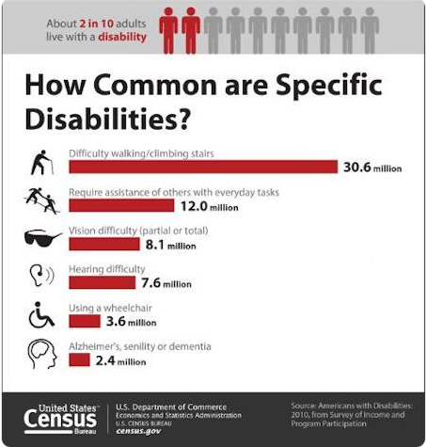 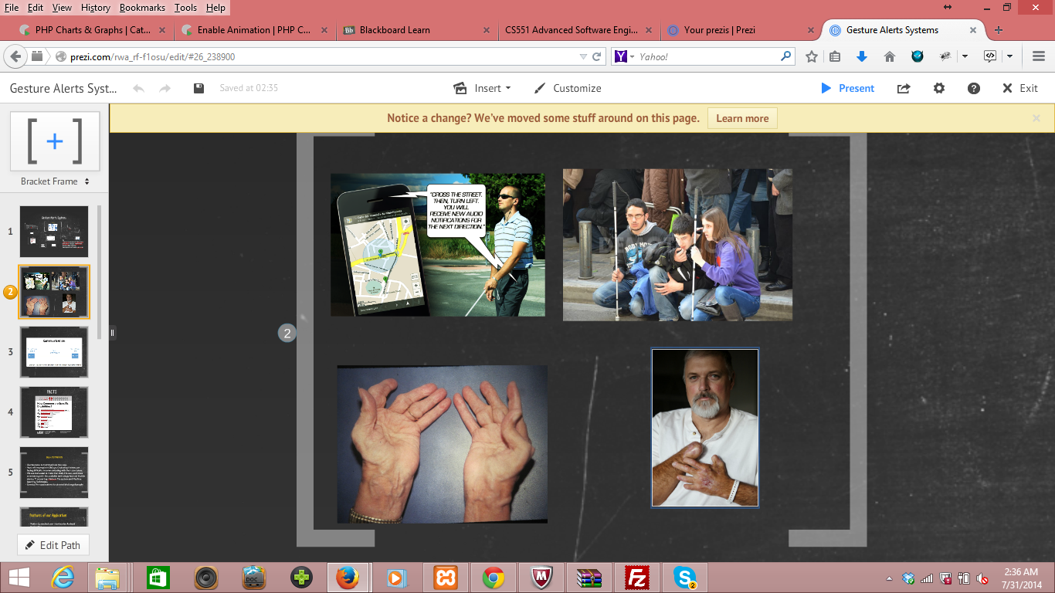

This motivated us to help those people with disability and to make their daily life easy.To achieve that we have developed an Android app in the mobile device using a TI sensor tag**.** To reduce the language barrier between two people of different regions we are introducing a common gesture language, which can be translated into any language easily.

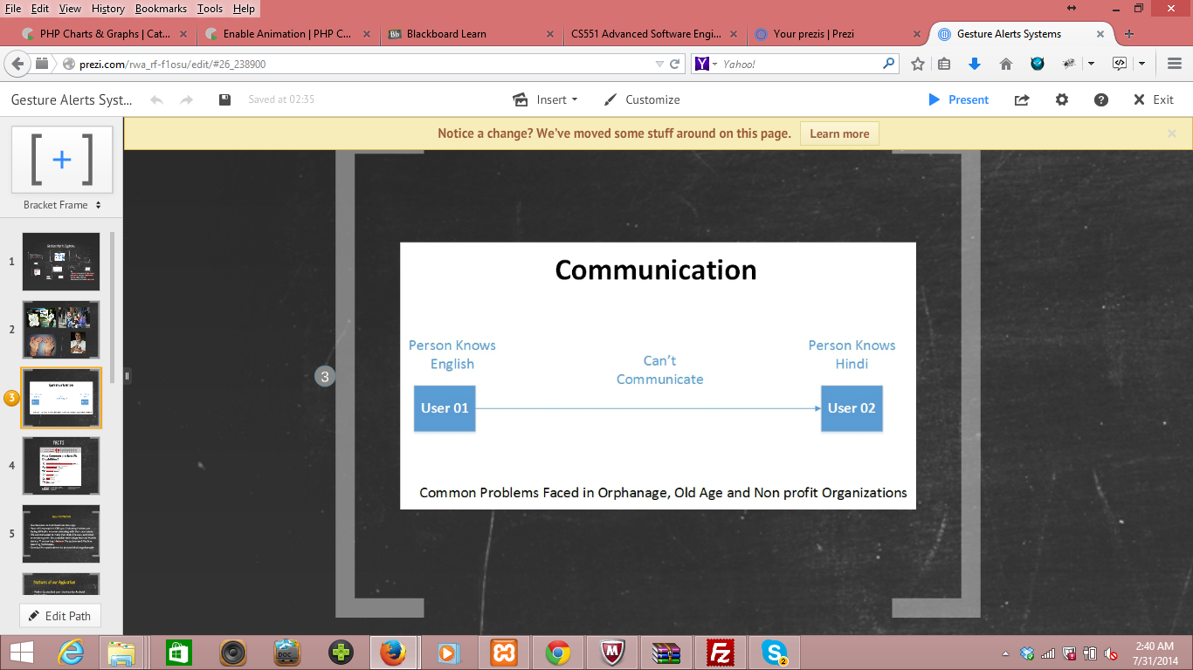

**Significance**

Our project is developed using a Texas Instrument sensor tag and an Android mobile device which is very helpful for the physically challenged people to convey their messages or intention using the gestures easily to the concerned persons at any where and provides some fun through the games.Our main motto is to develop an application which provides relaxation to the disabled and parallely to have a gesture alert system.

It is hard for elderly, disabled person to convey the message to a person whoever concerned i.e., his caretaker or an incharge of his nutrition that he is hungry or feeling thirsty and if he needs any kind of help at emergency.This can be made easy by our application using an accelerometer and a sensor tag.

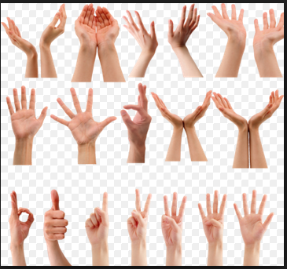

persons with Muscular dystrophy,post polio syndrome and Arthritis are some kind of joint disorders that involves inflammation of one or more joints are increasing day by day and they cannot access the mobile phone or convey their feelings as a normal person.These are made easy by our app as we are providing a gesture recognition mechanism with the text or e-mail alert along with the voice messages. Some of the examples of physical disability are Amputation, Arthritis, Upper limbs, Multiple Sclerosis, Muscular dystrophy, acquired spinal injury and post polio syndrome.

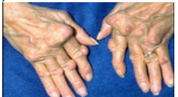

**Person affected with Arthritis**

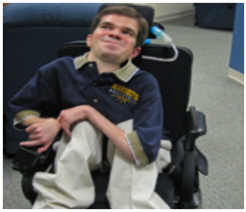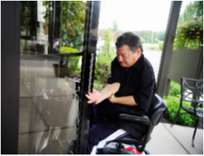

**Persons with muscular dystrophy and post polio syndrome**

Our application acts as a communication medium for the people who are unable to communicate with their caretakers or in the case when the person is unable to communicate his emotions because of lack of knowledge in the language. It is not simple task to learn the language of disable by all the people and to know all the gestures that are performed by them. These gestures are being captured by the sensor tag and using the KNN and the HMM algorithms on the gestures and are conveyed thus converting the gesture movements to the voice and text formats.

**Objectives**

* Text alert service for the caretakers of disabled people when he is feeling thirsty or hungry without facing difficulty with verbal language.
* An emergency alert system which directly sends message to the concerned person if the person needs help.
* Sickness Alerts to Care Taker’s and Doctor’s.
* Fun (Game) activities for Mental relief and Entertainment.
* Report and Physical Trainer service helping the disabled people to be fit and tracking their location.

**System Features**

* Motion Controlled user interface for Android Application
* Alert Message Service
* Game Applications
* Report Service about your recent locations, duration of stay, Number of gestures performed every hour daily.
* We are providing a Alert service to Care taker’s of visually challenged people by motion gestures related to feeling hunger, need some water, power short circuit etc., given by users through text messages.

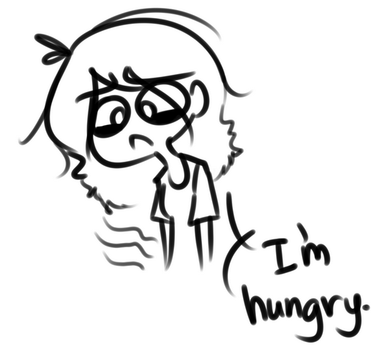 

* We can also develop a physical trainer application which recommends and instructs some fitness programs based on their Body Mass Index. At the end of the workouts session we will provide him a feedback about his exercise using our open source text file which records everything done with application.

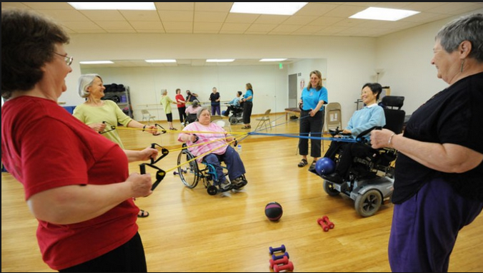

* We are providing a sickness alert service to physician and doctor in charge regarding the person using temperature sensor.

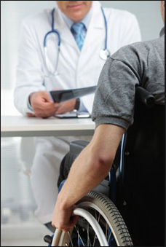

* We are also providing some entertainment with fun activities for a visually challenged person using TI sensor.

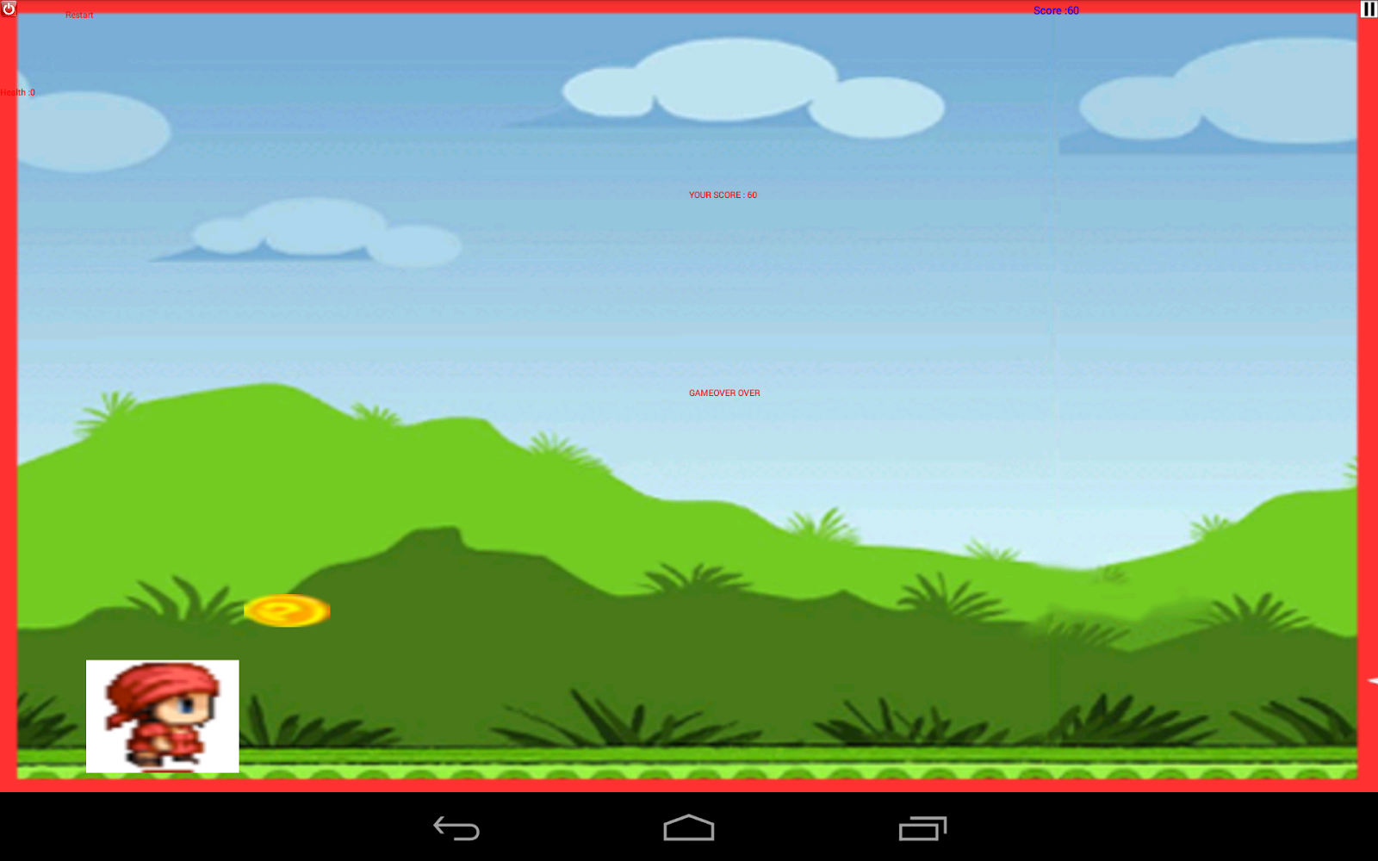

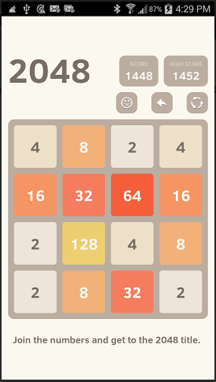

**Specifications:**

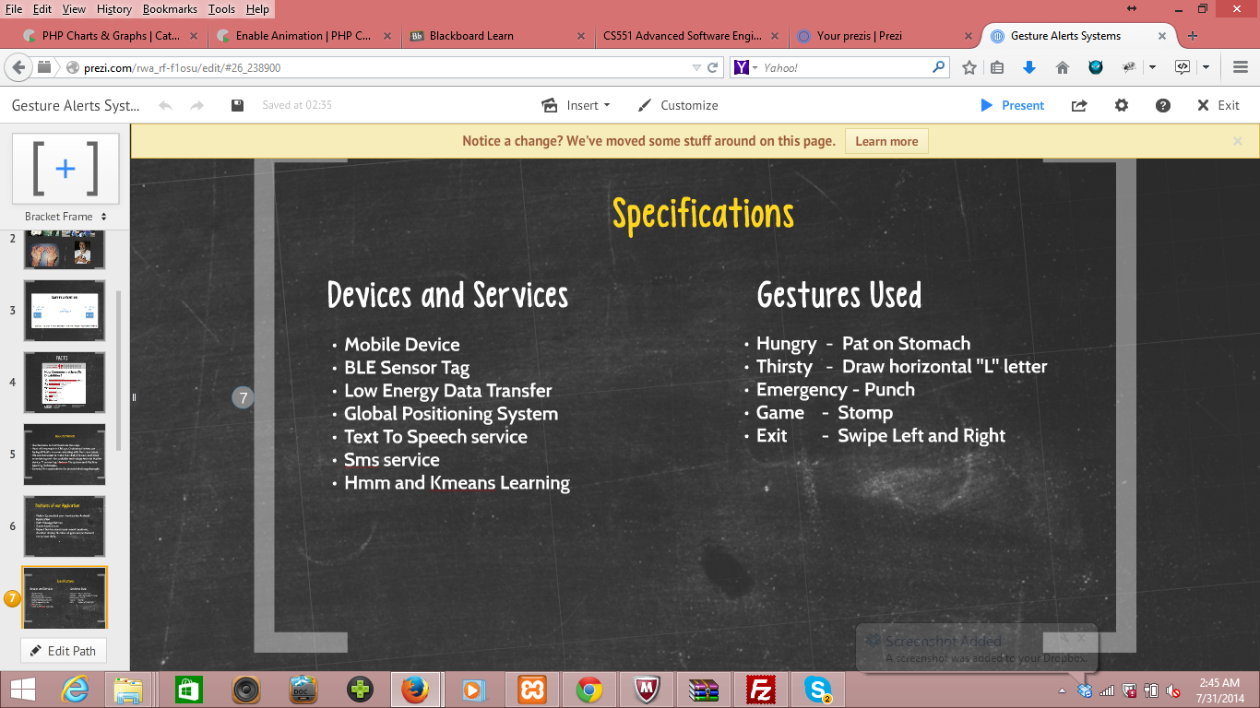

**Flow Chart:**

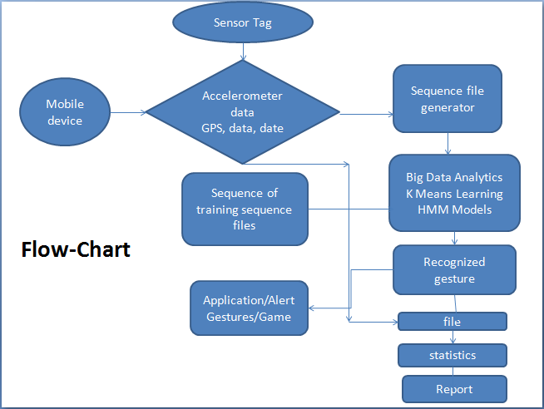

**System Architecture:**

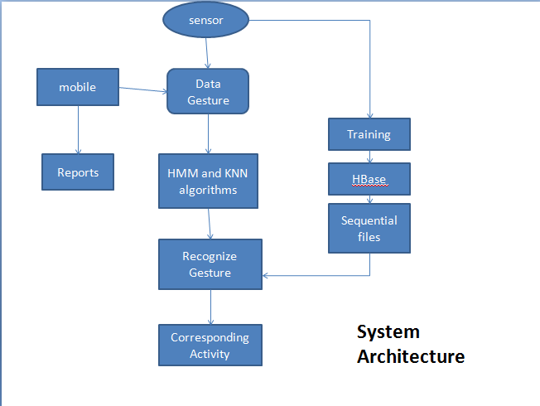

**System Architecture**

**Class Diagram:**

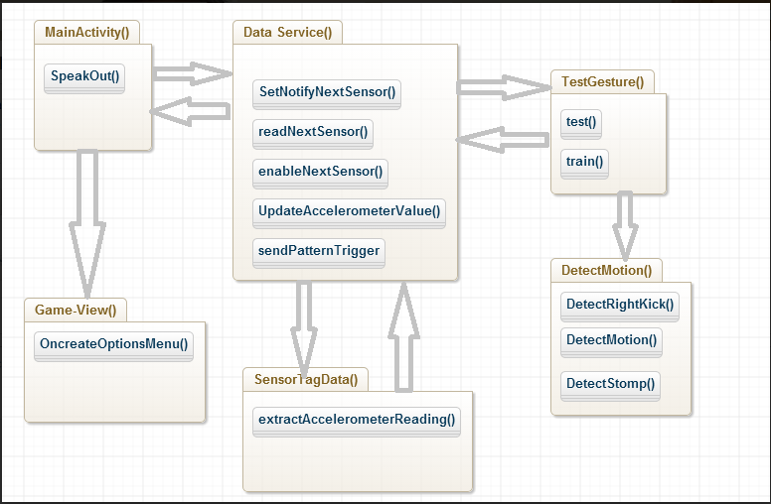

Online Application: Game by Motion

**Devices/Sensors**

**BLE sensor tag,mobile-gps service tag**

The CC2541 Sensor tag developed by Texas Instruments is used to detect and listen the gestures given by the persons which are required for the Application.This device is capable of detecting and sending the data related to the senses and they are described below

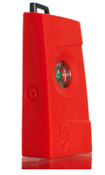

* The IR temperature Sensor embedded in it is used to measure the temperature values.
* The humidity factor in the environment is detected by the Humidity Sensor**.**
* The pressure control points are detected by the pressure sensor.
* This device also supports accelerometer data depending on the weight factor experienced by the sensor.
* The Gyroscope feature of this device measures the orientation based on principles of angular momentum.
* The Magnetometer in this device is used to sense the magnetic field and its strength in the surroundings.

Thus, [CC2541](http://www.ti.com/product/cc2541) Sensor Tag is the first Bluetooth Smart development kit focused on wireless sensor applications and it is the only development kit targeted for smartphone app developers making Bluetooth low energy app development easier and faster,including temperature sensor, humidity sensor, pressure sensor, accelerometer, gyroscope and magnetometer.

**Motion Models**

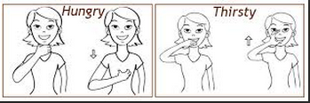

In our project we have taken five different motions to represent the required gestures. Description of each gesture is given below.

**Hungry:** For this gesture,we’ve given an expression using single hand motion according to the x and z axes.

**Thirsty:** For this gesture, we’ve given a flatened L alphabet motion captured in 3D plane.

**Game:** For the game gesture, we have taken a regular top down motion gesture with pressure which seems to be like a stomp with the han**d.**

**Emergency :** We used a punch in z axis for this gesture**.**

**Exit :** We used a horizontal left to right swipe for this gesture.

**Game Logic/Features**

**2048 game and got to run:**

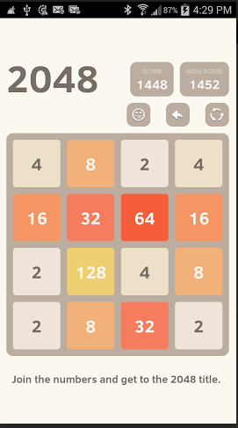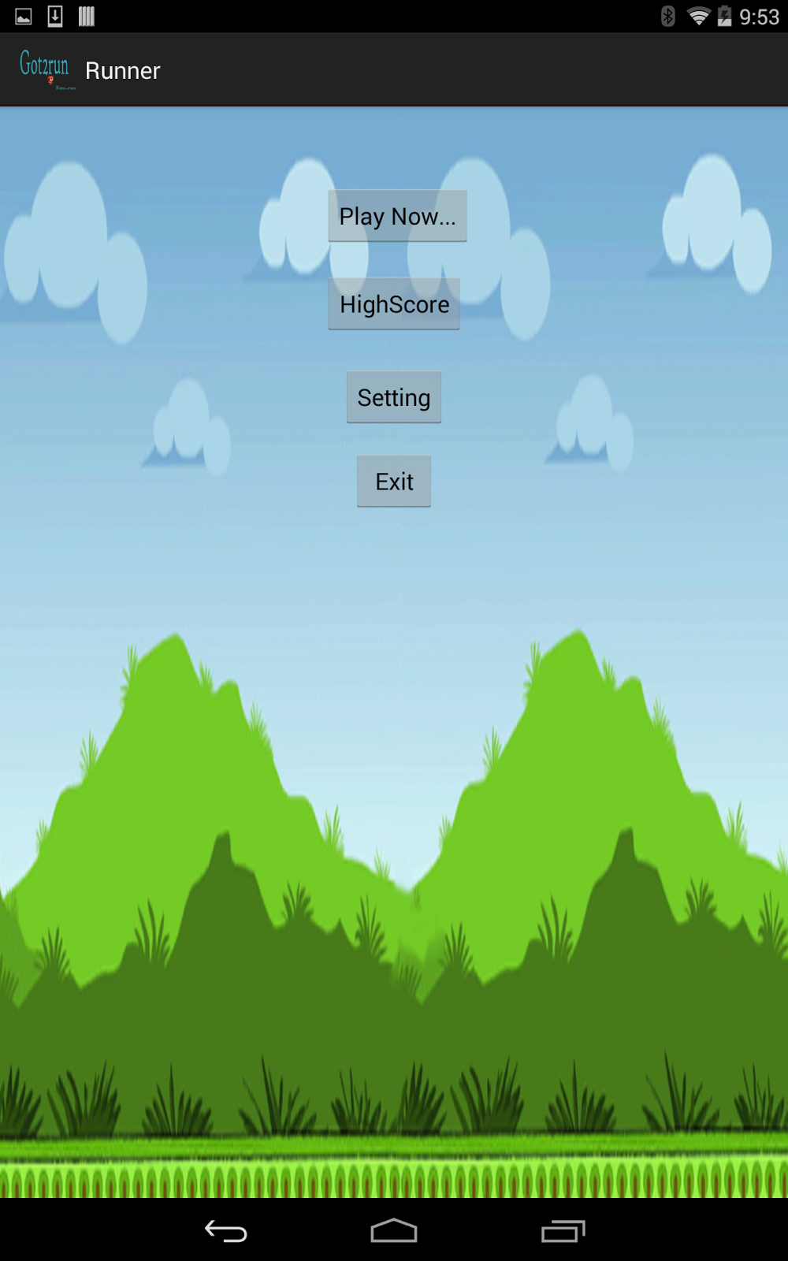

We have imported 2048 and The Got to run game from the internet resources and tried to replace the ontouch event with the recognized gestures from accelerometer data of the BLE Sensor Tag.These android games runs in the eclipse platform which is compatible with all the screen resolutions.We have given motion control to select, start, change settings and exit the game.

**Recognition/Analysis Approaches (Workflow, Algorithms, Input/Outputs)**

* The Accelerometer and Gyroscope data is collected from BLE Sensor as a text file with tab seperation.
* We are generating a sequential file on filtering the noise and the idle state data collected from sensor tag by applying mathematical expressions on accelerometer data.
* Then, we are training the classifier with the training sequential files of each action. For our project we had trained five gestures till now.

1. Pat on stomach - To notify the Care taker that the user is Hungry.

2. Flattened L alphabet - To notify the Care taker that the user is Thirsty.

3. Top down motion of hand - To activate and play games.

4. Punch in Z - Axis - To send Emergency alert.

5. Left to Right Swipe - Replaces Back button in Android Activities in our application

* Here, we are using open source games Got2run and 2048 games for our Application
* This sensor text files are uploaded into the HBase using a web Service.
* We are also looking towards training the classifier using Wiigee library now.
* Machine learning algorithms of R / Mahout uses the data in Hbase for providing Alert services and Physical trainer services from Accelerometer and Temperature data.
* We use HMMM Motion recognition algorithm to detect the required motions given by user upon a training set of three gestures.

**System Features and Android App GUI (screen captures)**

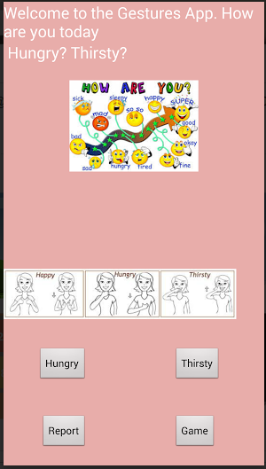

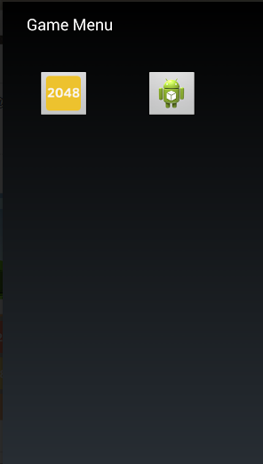

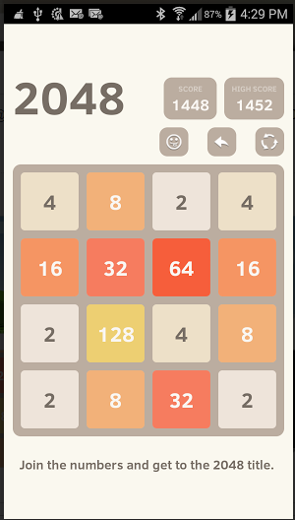

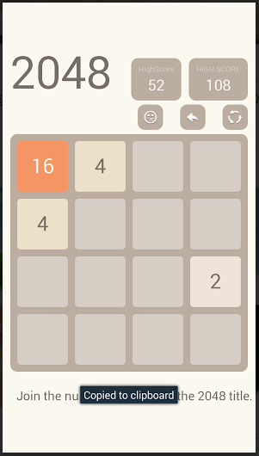

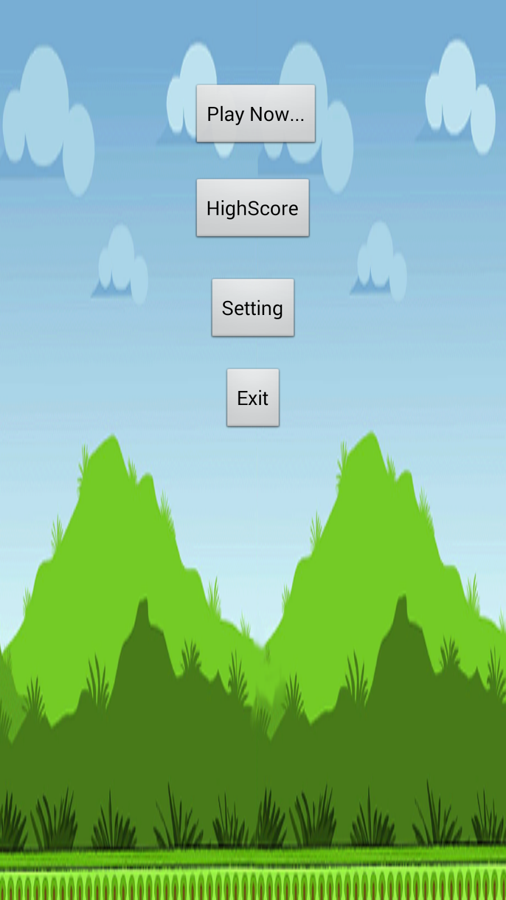

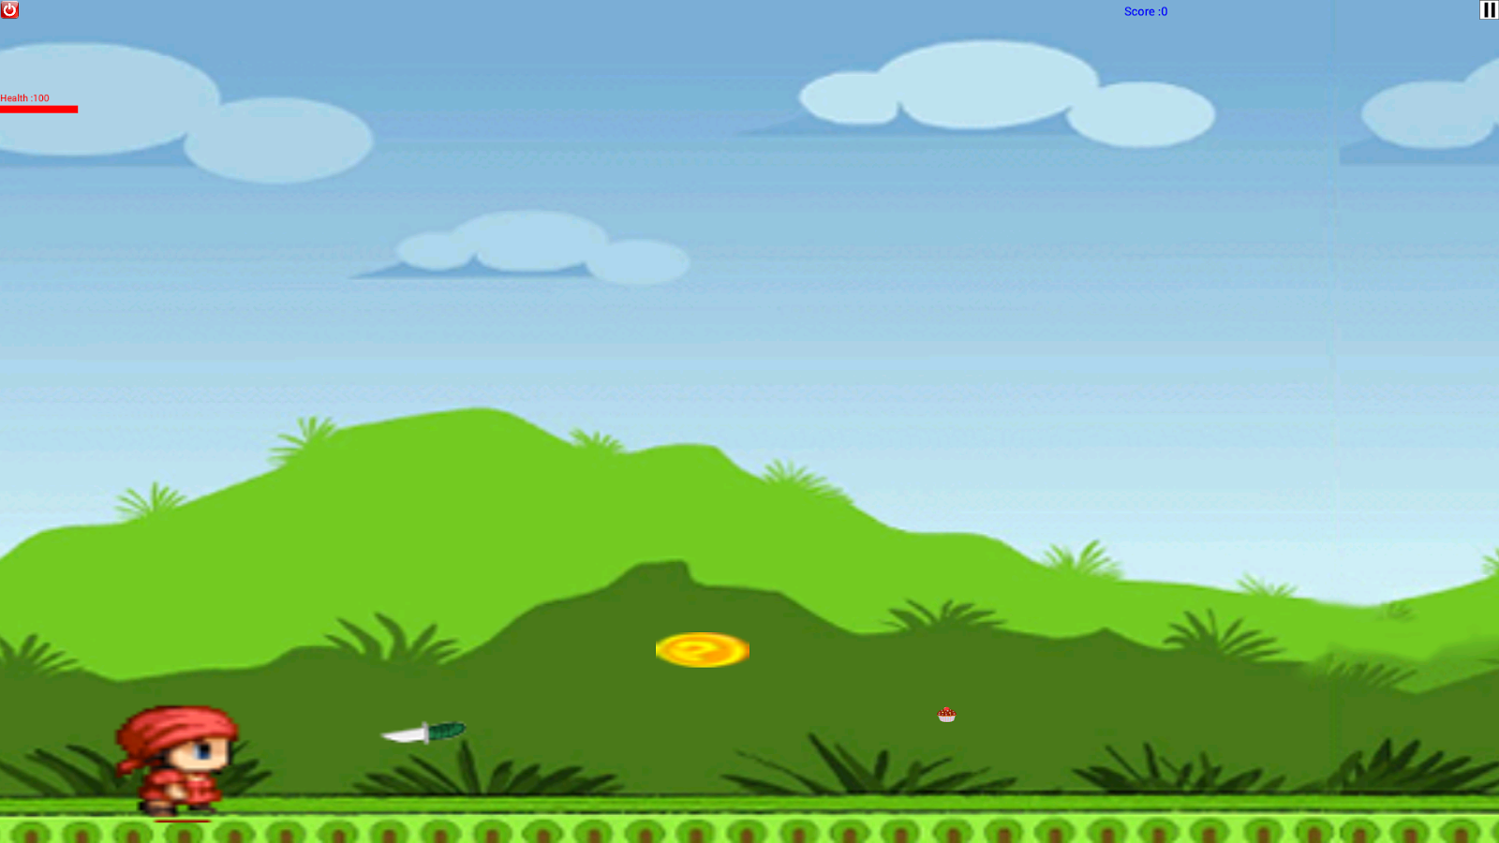

**Offline Application: Activity Report**

We are generating a text file that tracks all the activities done by the user with the application.

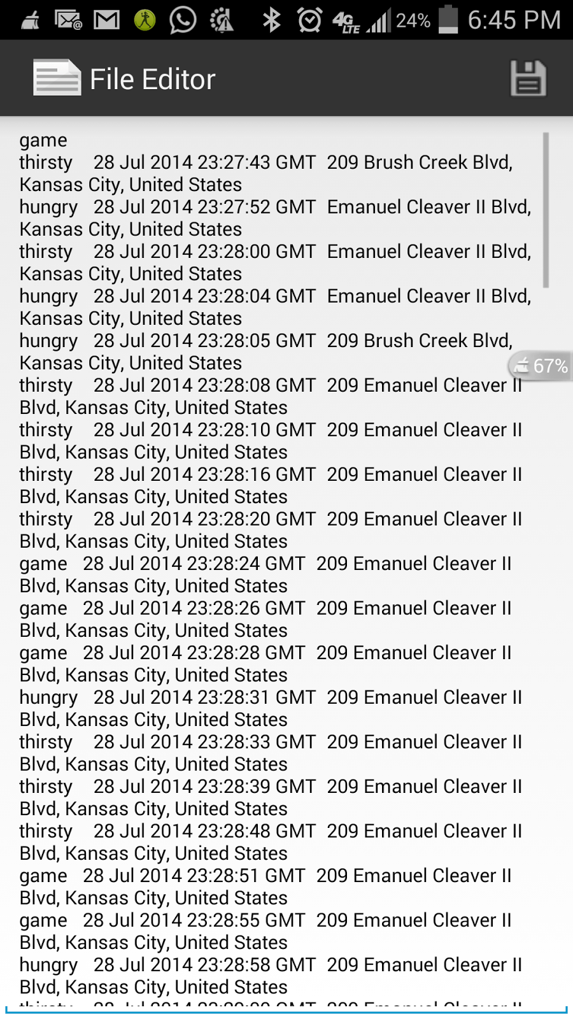

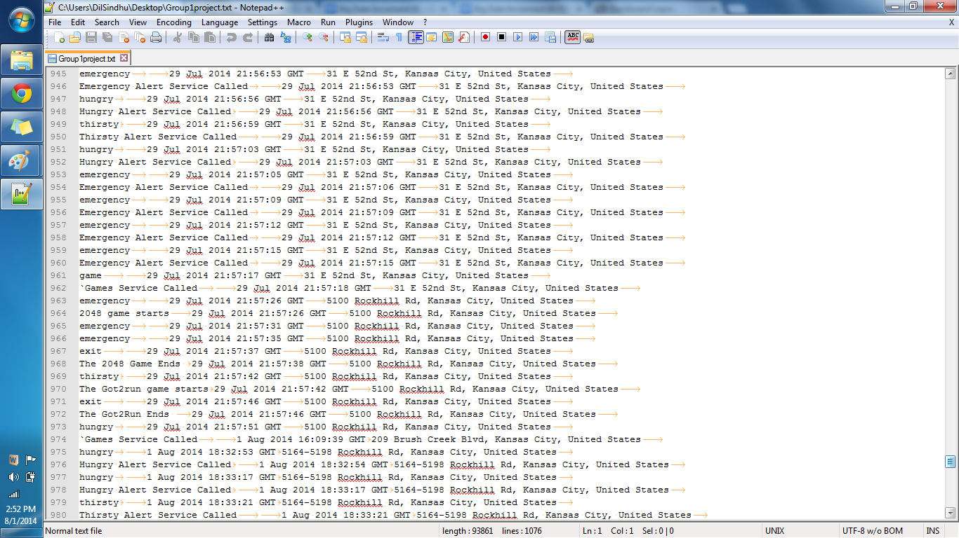

We are using the text file data to produce reports and charts as below.

**Activity Models**

An open source code is imported under the name of AchartEngine

.Version 0.2.0 was launched which is the first open-source charting library for Android. At that time, Android SDK was at version 1.1.It is a charting library which supports line chart,area chart,scatter chart,time chart,pie chart etc and can be displayed with the X axis horizontally or vertically and support many other custom features.They can be added to any group inorder to view and can be used to start an activity.

**Features**

* **This model and the graphing code is well optimized such as it can handle and display huge number of values.**
* **There are three main types of charts supported by AChartEngine:**
* **XY charts display the data on the 2 axes**
* **Round chart display the data using pie diagrams**
* **Combined chart is used ti display the combination of both the XY charts.**

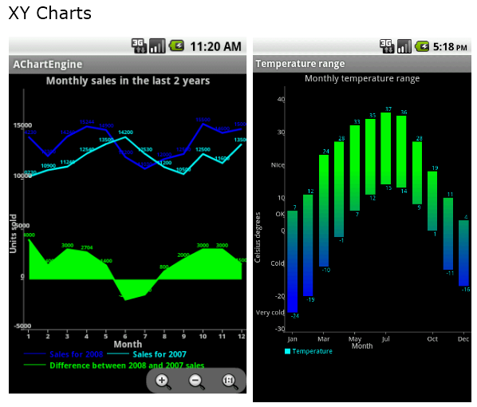

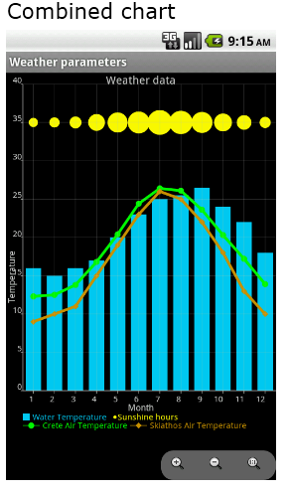

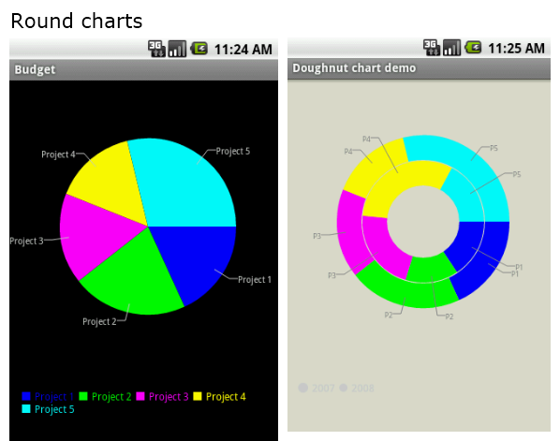

**Recognition/Analysis Approaches (Workflow, Algorithms, Input/Outputs)**

* The AbstractChart class describes the behavior that is shared by all the charts,including drawing the background,legend,titles etc.
* The XY chart class describes state and behavior that is common to the XY chart type like the rendering of the axes,labels etc.
* The RoundChart is similar to XYChart,but for the chart types that have a circular shape.

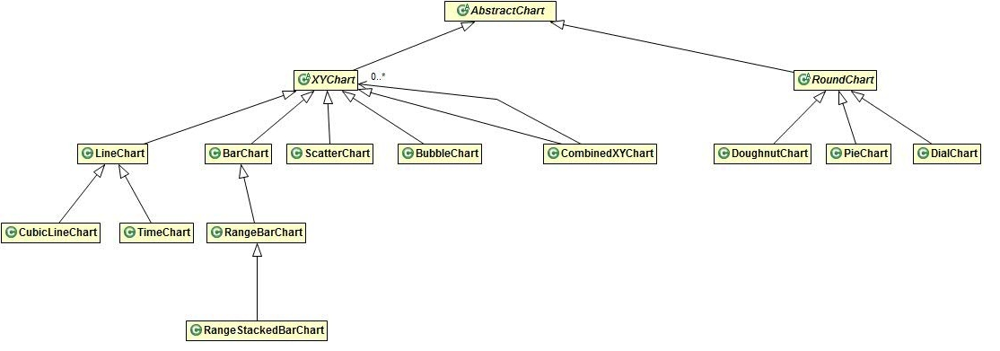

**System Features – Software Architecture, HBase Design and Android App GUI (screen**

**captures)**

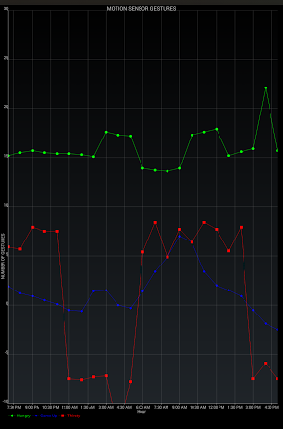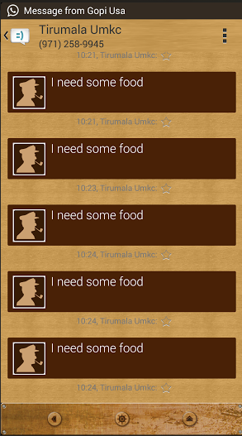

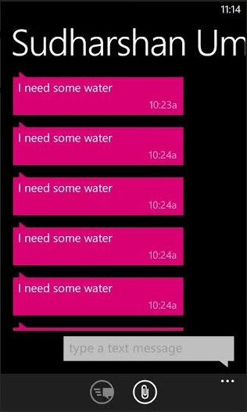

**User Manual:**

* Users need to install our Android Application by running our code in eclipse or installing our Apk.
* Users need to store our training sequence files in their Data folder.
* Users need to turn on Bluetooth, GPS , Internet and Sensor Tag Device before starting this application.
* Please wait for 30 secs to train all gestures.
* Then start using application with the below controls.

**Gesture Controls in our Application:**

|  |  |  |  |  |  |  |
| --- | --- | --- | --- | --- | --- | --- |
| **Gesture / Activity** | **Main Activity** | **Game View Menu** | **2048 Game** | **Got 2 run Menu** | **Got 2 Run Game** | **Report View Menu** |
| **Hungry** | Hungry Alert |  | Up | Play Now | Resume | Line Chart View |
| **Thirsty** | Thirsty Alert | Got2Run Menu | Left | Setting Menu | Pause |  |
| **Emergency** | Emergency  Alert | 2048 game | Right |  | Jump | Recent Locations and Duration |
| **Game / stomp** | Game Menu |  | Down | High Score | Restart Game |  |
| **Exit** | Report Menu | Back to Main menu | Back to Game View Menu | Back to Game View Menu | Back to Got 2 Run Game Menu |  |

**Evaluation: Motion/Activity Recognition**

**Types of Motions/Activitieso Size of data, Number of Gestures**

Each gesture is tested for about 20 times

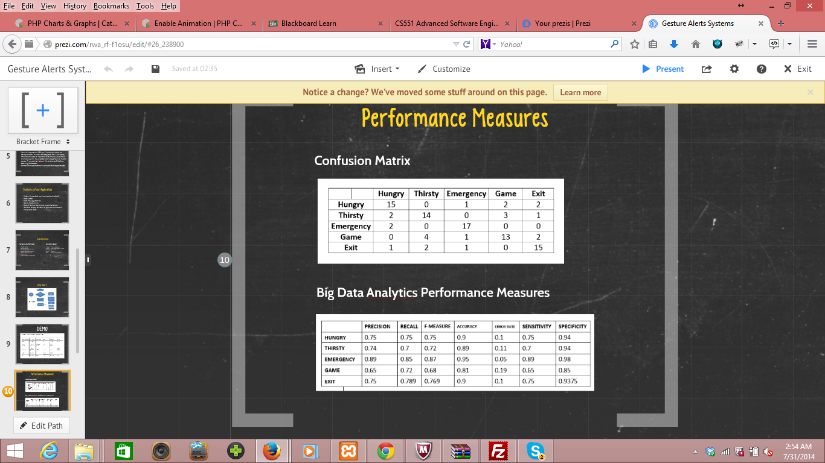

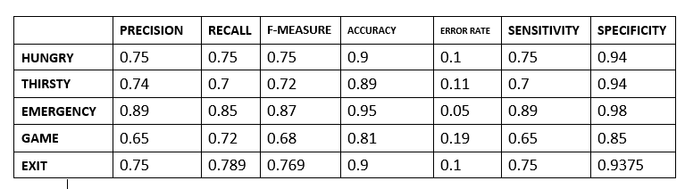

**Limitations**

The app doesn’t support any inbuilt sensors. This application is designed exclusively to work with BLE sensor tag designed by Texas Instruments.

**Future Scope**

We are looking forward to develop a gesture language to communicate brief messages, to reduce language barrier in communicating with people of various regions. We are working to develop more number of gesture recognition and alert systems for few more emotions which need to be taken care by the caretaker for the disabled persons. We can predict the probability of user being sick depending on the body temperature values captured by the sensor thereby reducing the overhead of hospitals on the users.

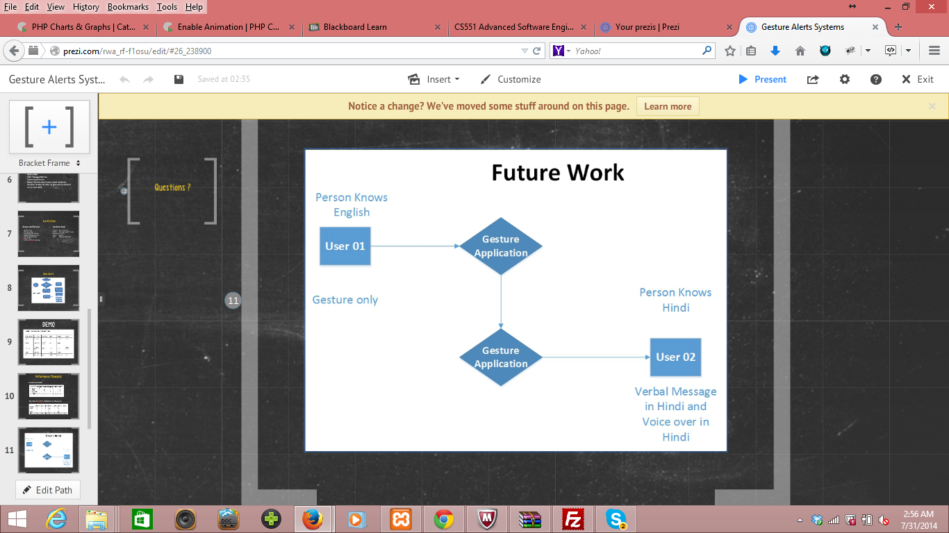

# Project Management Report

As part of our Project Management, We had used ScrumDo Website for planning our tasks among our team mates.

**Increment 01:**

We had completed the following Tasks for our Increment 01 in ScrumDo

1. Tirumala reddy - Study gesture recognisition, Hbase.

2. Divya sree - Design of User Interface

3. Krishna Chaitanya - Open source game collection

4. Syamala Reddy - Open source game collection and scrumdo

**Scrumdo:**

We used scrumdo for planning our tasks for this first increment as below.

**Scrumdo Url**

<https://www.scrumdo.com/projects/project/lab-012/iteration/103668>

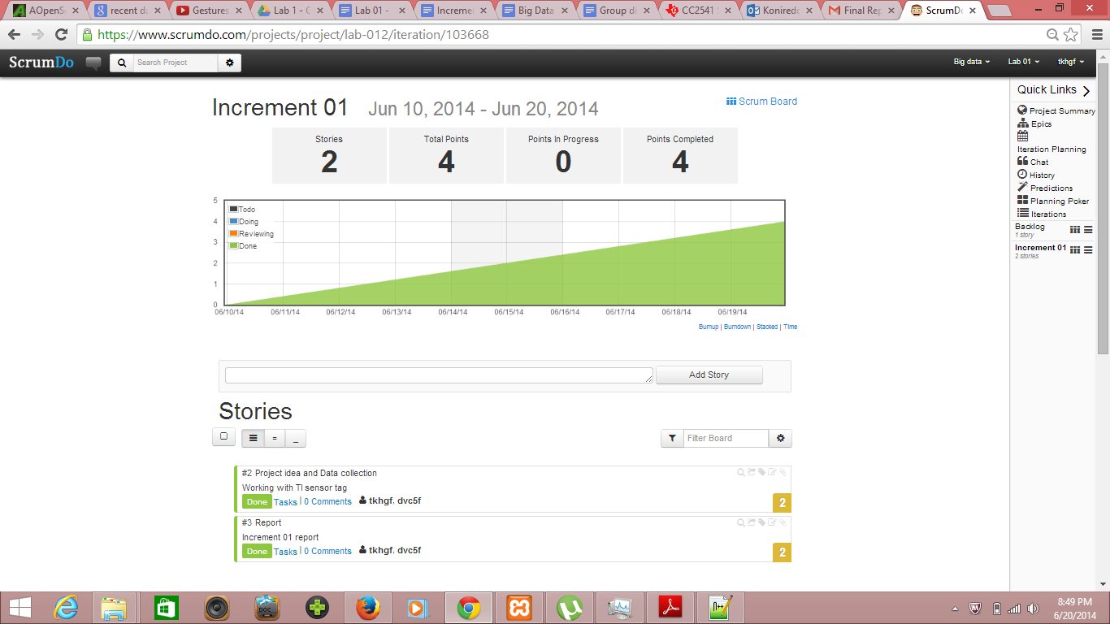

**Increment 01**

**Increment 02:**

We had completed the following Tasks for our Increment 02

1. Tirumala reddy - Collection of accelerometer data into sequence files.

2. Divya sree - User Interface

3. Chaitanya - Open source game collection

4. Syamala reddy - Documentation and Open source game collection

**Increment 03:**

We had completed the following Tasks for our Increment 03

1. Tirumala reddy - Integration of games and usage of recognised motions in code where ever necessary.

2. Divya sree - Finalized UI and development of sms service

3. Krishna chaitanya - Tried to integrate Hbase in our application.

4. Syamala reddy - Helped in Coding for broadcast receiver, and integration of games.

**Increment 04:**

We had completed the following Tasks for our Increment 04

1. Tirumala reddy - Final Integration of games and development of Report services, Video Production.

2. Divya sree - Integrate text to speech service and improvement of UI and Video Production.

3. Krishna chaitanya - Tried to store activity tracking results in Hbase.

4. Syamala reddy - Final documentation and presentation.

# Final Project Evaluation

### Discuss how well your project satisfies your original requirement specification.

We successfully gathered data from various Open source game sources and integrated motion recognition technology, Kmeans and Hmm observation vector into them. We had also integrated alert service using sms manager and audio feed back service using text to speech service. We are very satisfied with our project as we had done all the things that we had planned at beginning.

**Were you satisfied with your design process?**

Yes, we had covered all the activities that we had planned to do in our project.

### How helpful was the agile process?

The agile process was helpful in planning an overall project’s requirements.

**How would you do the agile process next time?**

Until an employer leverages performance requirements against production work, we would continue to perform as needed to accomplish necessary academic gains. That is to say, timelines and workloads are whatever and wherever we are comfortable having them so long as we are productive in meeting our end goal using reasonable time and resources to get there. Nevertheless, agile process is a good exercise to build awareness.

### Did you stick to your project plan schedule?

Communication among active participants was regular. At the beginning of every new increment, we had clearly defined goals and expectations. Who was working on what, and when it could be expected was always clear. Any delay was properly communicated. There were regular setbacks or delays in the project ultimately resulting in unfinished components, but these were always made clear to the invested contributors. At the end of every increment, contributors always met to update documents and realign our goals and activities.

### What was the real management structure within your group?

We used online collaborative tools courtesy of the Google Drive and Google Plus platforms to communicate remotely and share documents and data. We incrementally scheduled meetings and we were fortunate that our schedules aligned in such a way as to meet on critical deadlines whether in person or online. Anyone that expressed a project need or concern was accommodated by others. Dr. Lee was clear in her expectations of project deliverables and our group was responsible in producing deliverable works. The workload was evenly distributed among those who chose to participate.

### Does it bear any resemblance to structure that you had planned?

We informally planned everything after increment one. In spite of lacking formality, our planning did evolve a precise structure. For every increment, we would identify work previously completed based on our original plan. During the increment reporting process, we would identify the next segment of work to be completed by each person in preparation for the following increment. In between increments, we met after class to share progress and demonstrate working contributions to our project.

### Did you have any problems getting each member to do his/her share of the work?

No problems.

### Do you have any suggestion on how this could have been handled better?

No.

### Discuss what you might have done differently if this were a real world project?

If this were a real world project, we would have to work harder and produce more work hours to accomplish our original objectives. Our Gesture Recognition Alerts, machine learning classifications and recommendations would have to be more accurate. A fully realized work flow would have to be produced to handle the constant stream of data. From back to front, it is possible to build a system that does all we wanted to do.

**Related Work:**

Many speech to text applications are available to store the notes or messages. Our application takes the input using gestures and alerts the trainer with their requirement.

https://play.google.com/store/apps/details?id=com.khymaera.android.listnotefree

The temperature sensor application gives the readings of temperature in specified scales. Our application alerts the user for any unusual temperatures of the user.

https://play.google.com/store/apps/details?id=com.dexterltd.temprature_sensor_lite

**References:**

<http://www.ti.com/tool/cc2541dk-sensor?keyMatch=cc2541%20sensor%20tag&tisearch=Search-EN#descriptionArea>

<http://en.wikipedia.org/wiki/Gyroscope>

<http://en.wikipedia.org/wiki/Magnetometer>

<http://en.wikipedia.org/wiki/Accelerometer>

<https://play.google.com/store/apps/details?id=com.dexterltd.temprature_sensor_lite>

<https://play.google.com/store/apps/details?id=com.khymaera.android.listnotefree>

<http://www.gosphero.com/games/>

<http://www.zwodnik.com/list/android/free-and-open-source-games-for-android/>

<https://play.google.com/store/apps/details?id=com.beatsportable.beats>

<https://github.com/search?q=android+game+dance&type=Repositories&ref=searchresults>

<https://github.com/xtbl/android_kids_world_animals>

<https://github.com/search?q=android+touch+game&ref=cmdform>